DESTINO 1

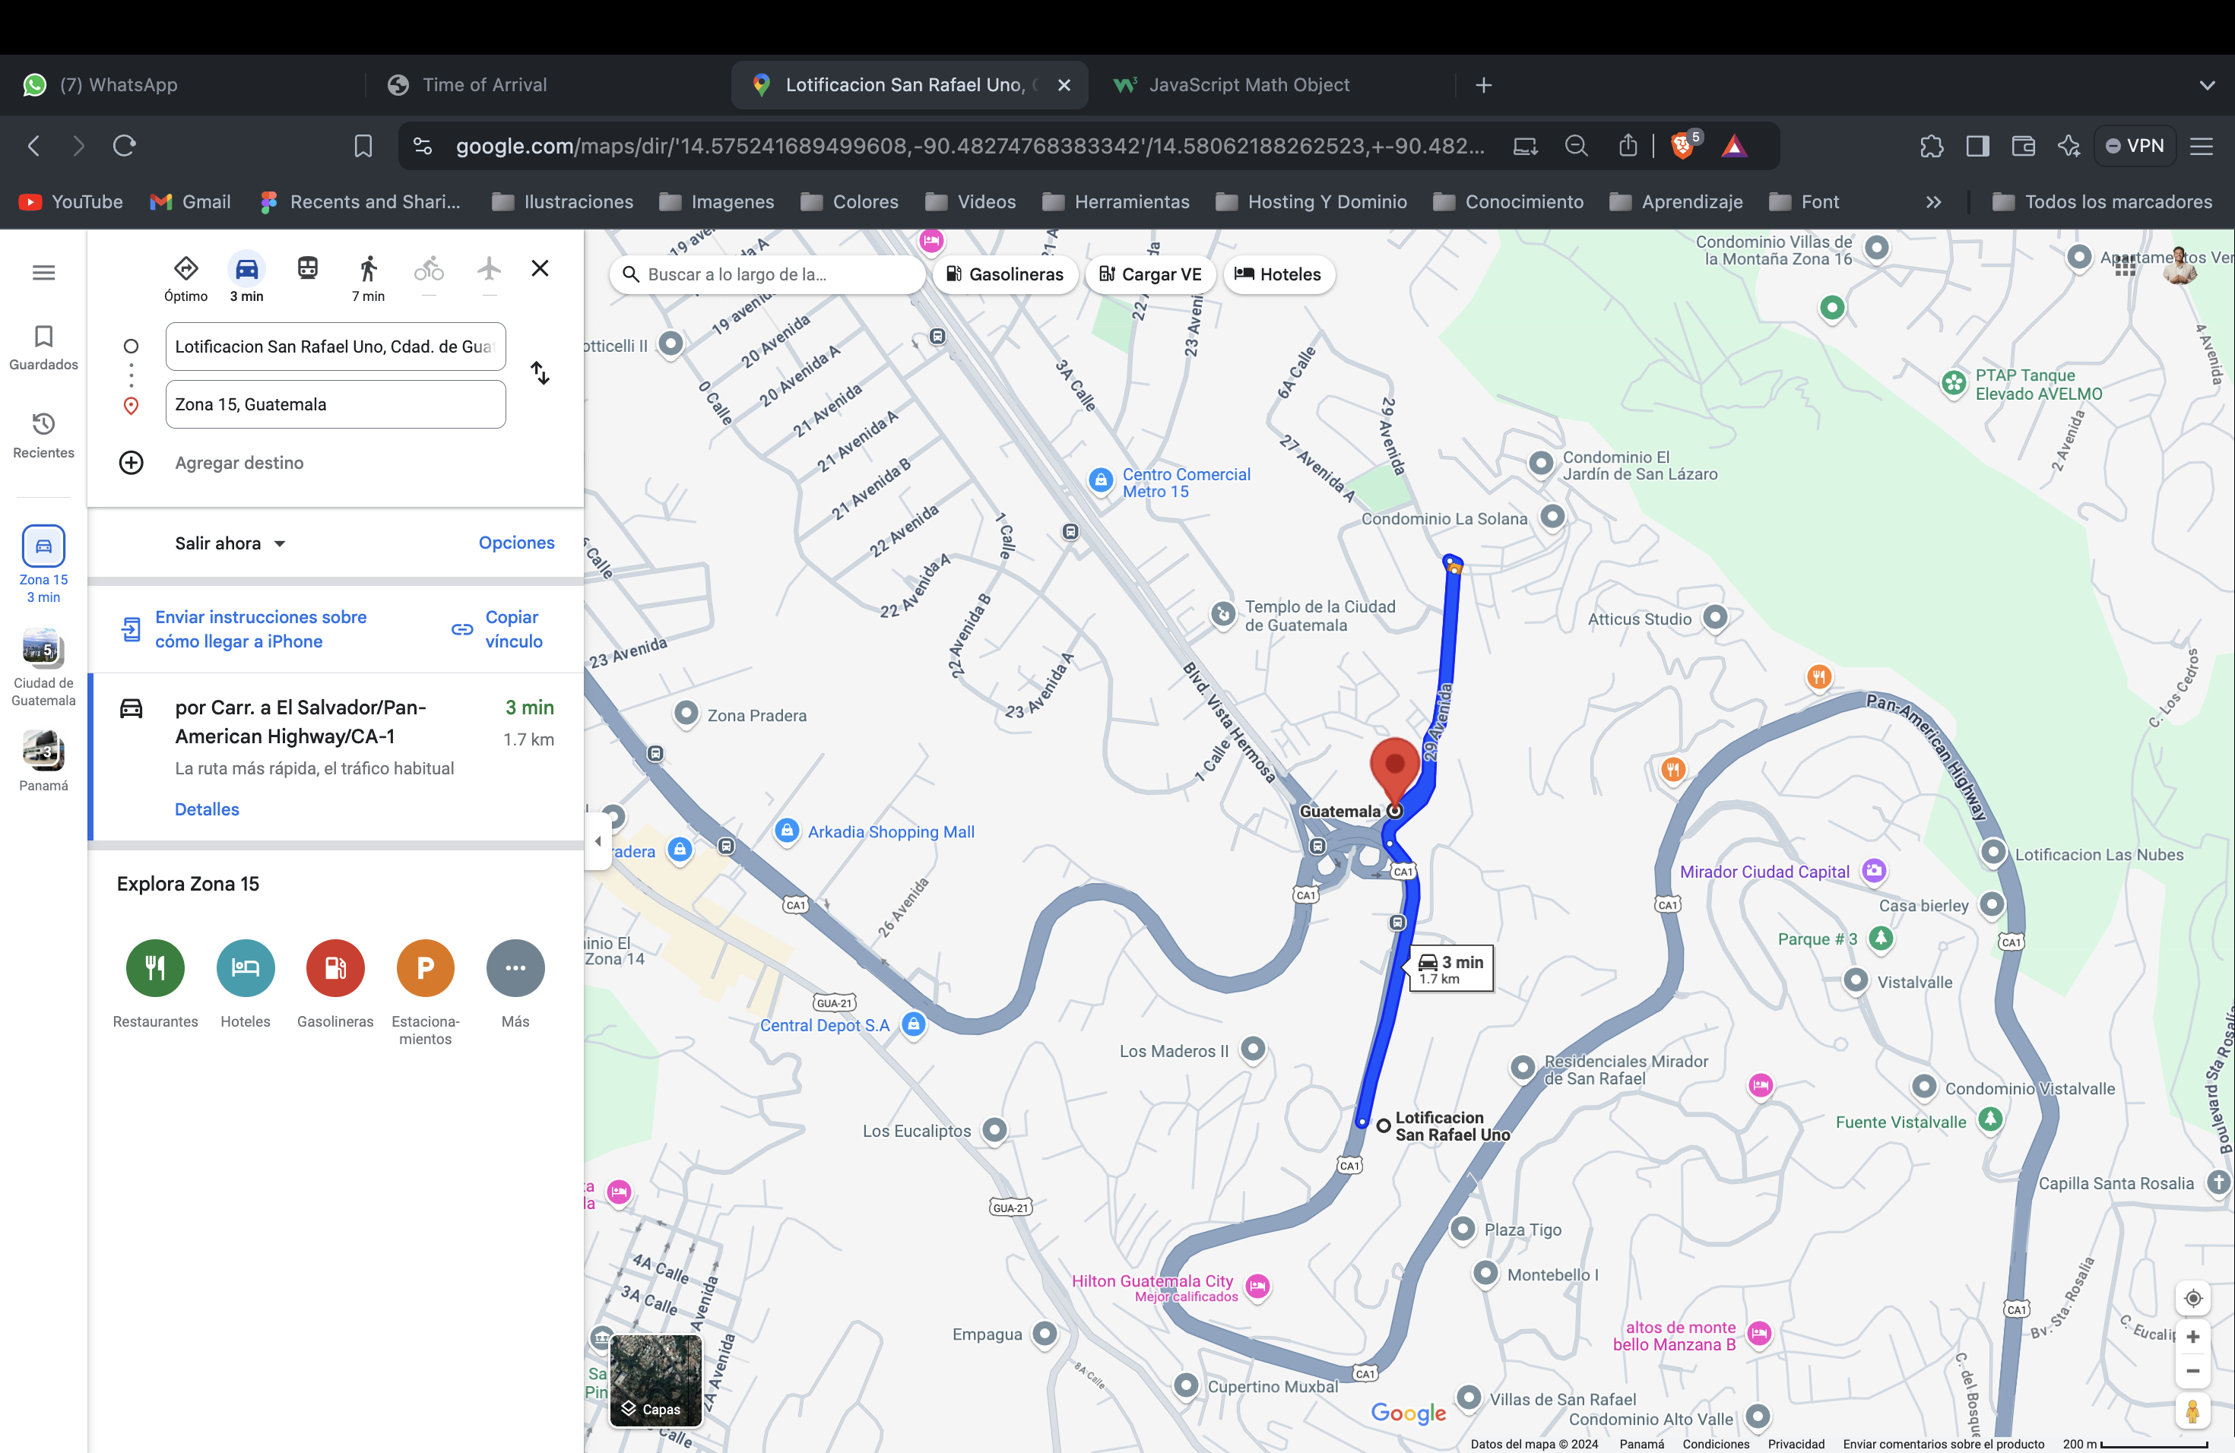

DESTINO 2

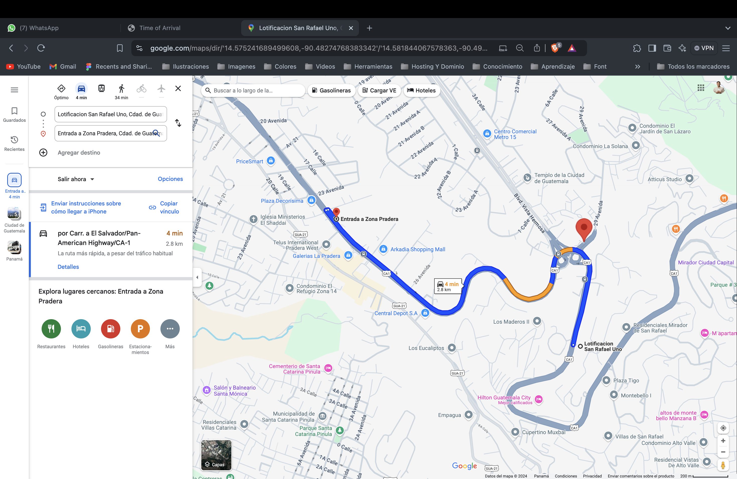

DESTINO 3

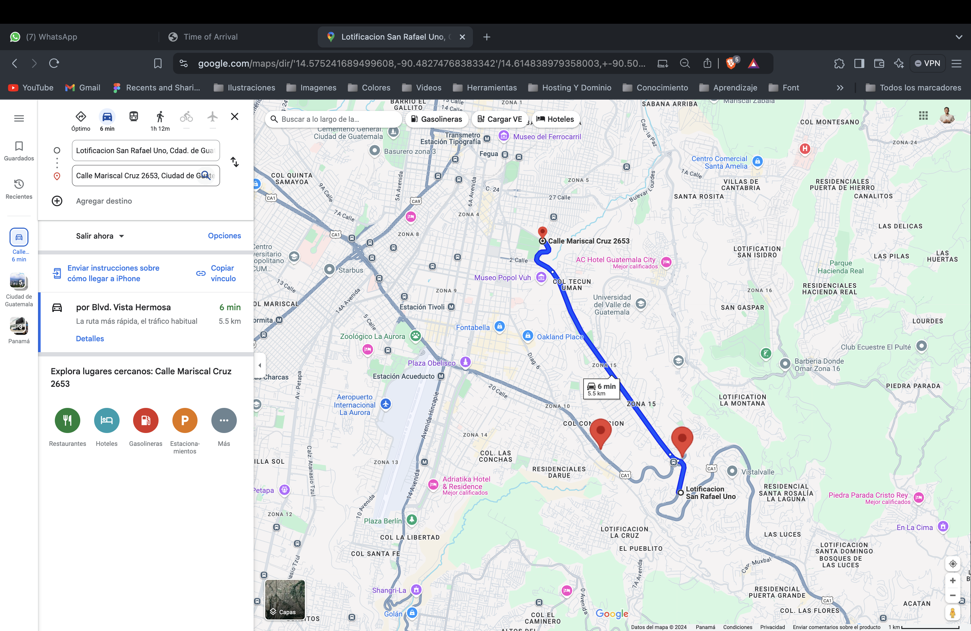

|  |  |  |  |
| --- | --- | --- | --- |
| **DESARROLLO** | | **GOOGLE MAP** | |
| **DISTANCIA** | **TIEMPO** | **DISTANCIA** | **TIEMPO** |
| 1.1 | 3 | 1.7 | 3 |
| 2.6 | 6 | 2.8 | 4 |
| 5.5 | 11 | 5.5 | 6 |